Development of Environmental Monitoring of parks

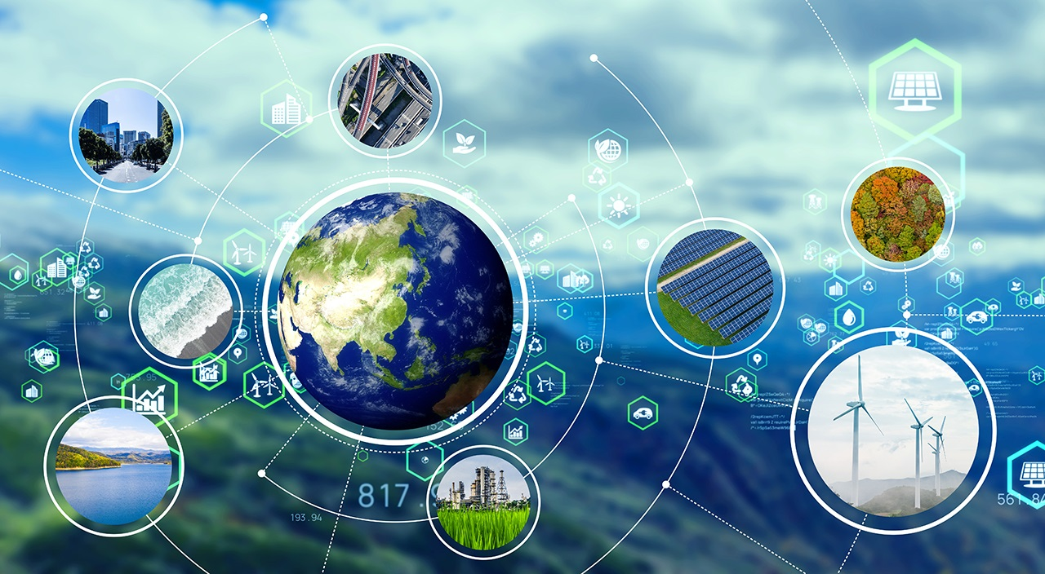

# IOT SENSORS

IoT sensors are pieces of hardware that detect changes in an environment and collect data. They’re the pieces of an IoT ecosystem that bridge the digital world to the physical world. IoT sensors may detect things like temperature, pressure, and motion, and if they are connected to a network, they share data with the network.

### 1. Temperature Sensors

Temperature sensors measure the amount of heat generated from an area or an object. They detect a temperature change and convert the findings to data. Temperature sensors are used in various industries, including manufacturing, healthcare, and agriculture. Some examples are thermistors, thermocouples, and resistor temperature detectors (RTD

### 2. Proximity Sensors

Proximity sensors detect the presence or absence of objects near the sensor without physical contact. They often emit a beam of radiation like infrared or an electromagnetic field. They can be used for process monitoring and control, object counting, assembly lines, and determining available space. Proximity sensors are common in retail settings, industrial complexes, and parking lots. Some examples are photoelectric, magnetic, capacitive, inductive, and ultrasonic.

### 3. Water Quality Sensors

As you’d expect, water quality sensors monitor the quality of water. They are often used in water distribution systems, but they function in a variety of industries. There are different kinds of water sensors, including residual chlorine sensors, turbidity sensors, pH sensors, and total organic carbon sensors

### 4. Chemical and Gas Sensors

These sensors monitor air quality for the presence of toxic or hazardous gas. They often use semiconductor, electrochemical, or photo-ionization technologies for detection. They are typically used in industrial and manufacturing settings, though they are also found in carbon dioxide detectors.

### 5. Humidity Sensors

These sensors measure the amount of water vapor in the air. Typical uses include heating and air conditioning systems (HVAC) and weather monitoring and prediction. When humidity must be tightly controlled, such as in museums, hospitals, and greenhouses, humidity sensors assist the process

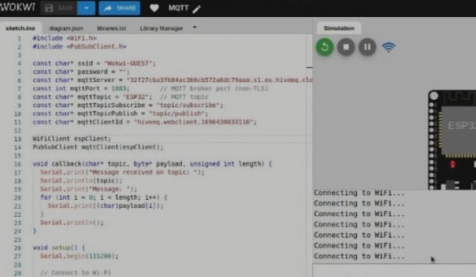

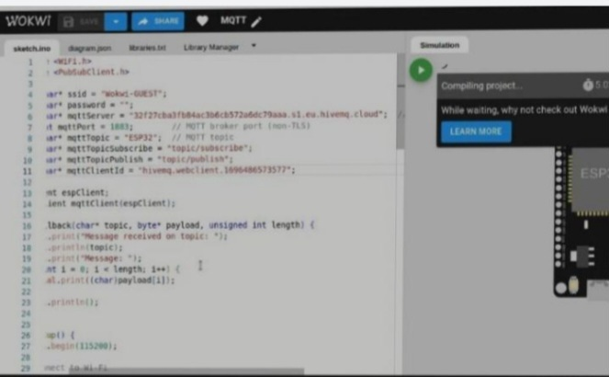

Working with Arduino

*in* order to understand this concept, first you need to know about free hardware and free software concepts. Free hardware are devices whose specifications and diagrams are publicly accessible, so anyone can replicate them. This means that Arduino offers the base **so that any other person or company can create their own boards** , being able to be different from each other but equally functional when starting from the same base.

Free software is a computer program **whose code is accessible by anyone** so that whoever wants to use  can use and modify it. Arduino offers the Arduino IDE (Integrated Development Environment) platform, which is a programming environment with which anyone can create applications for Arduino boards, so that they can be given all kinds of utilities.

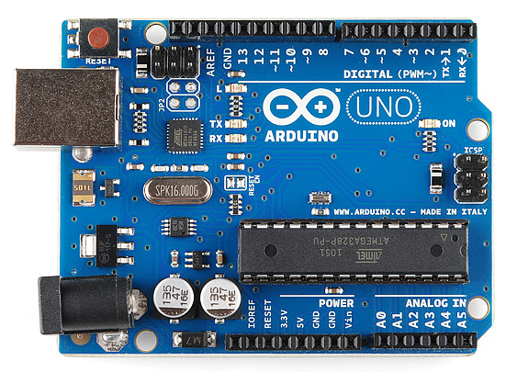

This Arduino project was born in 2003, In order to facilitate the access and use of electronic and programming Several students from the Institute of Interactive Design of Ivrea, Italy created it. They did it so that electronics students would have a cheaper alternative to the popular [BASIC Stamp](https://en.wikipedia.org/wiki/BASIC_Stamp) , boards which costs more than a hundred dollars in those days, So, not everyone could afford them.

There hard work resulted an Arduino, a board with all the necessary elements to **connect peripherals to the inputs and outputs of a micro controller**, and which can be programmed in Windows as well as macOS and GNU / Linux. A project that promotes the ‘learning by doing’ philosophy, which means that the best way to learn is by practically twerking the project around.